# Sign up for Github

1. Go to <https://github.com/> and sign up for Github
2. Create a repository (only one team member does this)

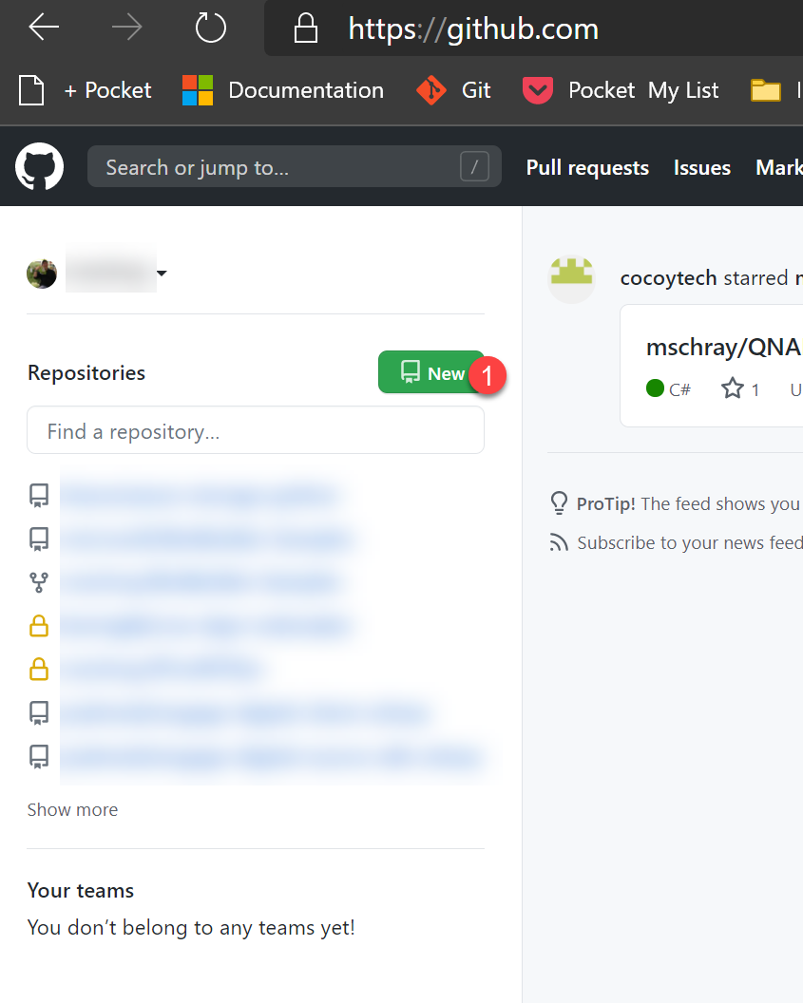

1. Invite other team members to the created the repo (e.g. repository)

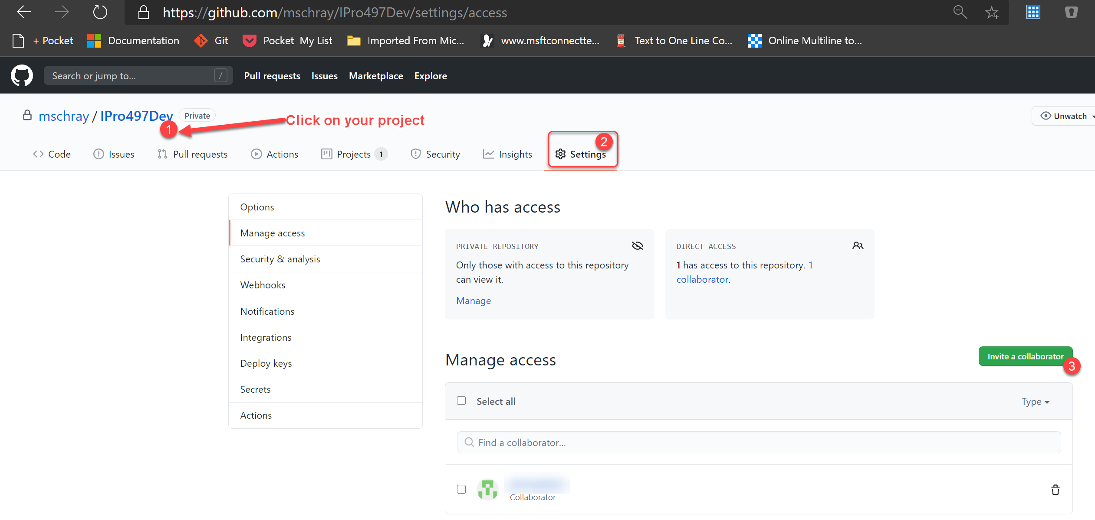

1. Invite your faculty member (RandGuth or mschray) to your repo
2. Create a repo for your code

